FSAK Logistics Website Requirements
1. Domain & Hosting
- Domain: fsak.sa
- Hosting: Hostinger (recommended, flexible for developer)

2. Language
- Bilingual: Arabic + English

3. Platform / Technology
- Flexible, developer can choose best
4. Website Pages
- Home
- About Us
- Services (6 services)
- Projects / Case Studies
- Contact Us / Request a Quote
- Blog / News

5. Homepage Sections
- Hero section (headline + CTA)
- About / Company intro
- Services overview (6 services)
- Featured Projects / Fleet showcase
- Testimonials / Clients
- Contact / Quote form
Exact layout flexible for developer.

6. Services Headings (Customer-Friendly)
- Land Transport
- Heavy Transport
- Customs Clearance
- Freight Services
- Warehousing
- Supply Chain

7. Contact / Quote Form
- Flexible for developer

8. Branding & Visuals
- Logo:
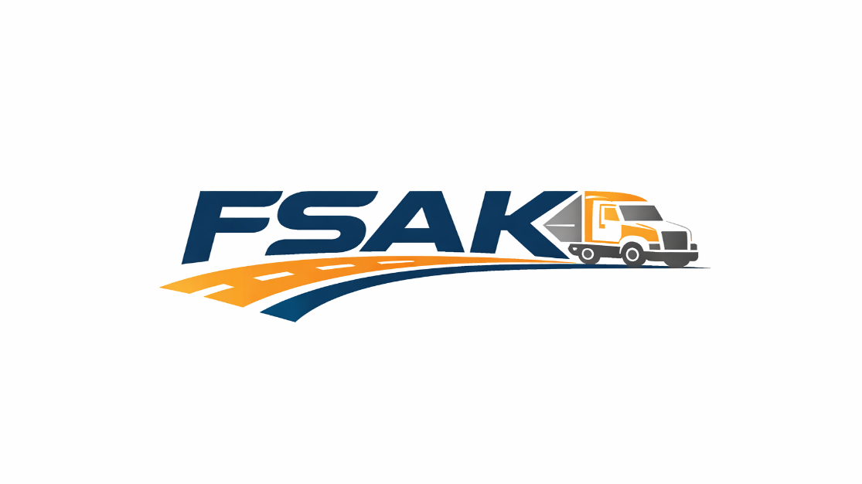

FSAK Tagline
Your Trusted Logistics Partner
(Deep Blue #004785 + Orange #FF8C00 + Dark Grey #222222)
- Colors:
  - Primary: #004785 (Blue), #FFFFFF (White), #222222 (Black/Grey)
  - Accent: #FF8C00 (Orange), #6B6B6B (Grey)
- Images: Stock images of trucks, heavy transport, warehouses, cargo, logistics operations
- Bilingual friendly design

9. Visual Style
- Bold, industrial, professional
- Clean layout, modern corporate feel
- Horizontal logo for header
- Buttons / CTAs: Blue / Orange
- Text: Dark grey / black

  - Contact Info
- Phone no : +966558736888 , +966552277603
- Email (info@fsak.sa)
- Location : An Nasr Rd, Al Masani, Riyadh 14714
- WhatsApp / Telegram (optional)

  - Social Media
- LinkedIn, Instagram, Facebook, Tiktok

